
Shocklogic Help Desk Google Chrome Extension

This extension will add a new button next to the address bar, when you click it will show you the latest Help Desk tickets assigned to you as in the screeshot below:

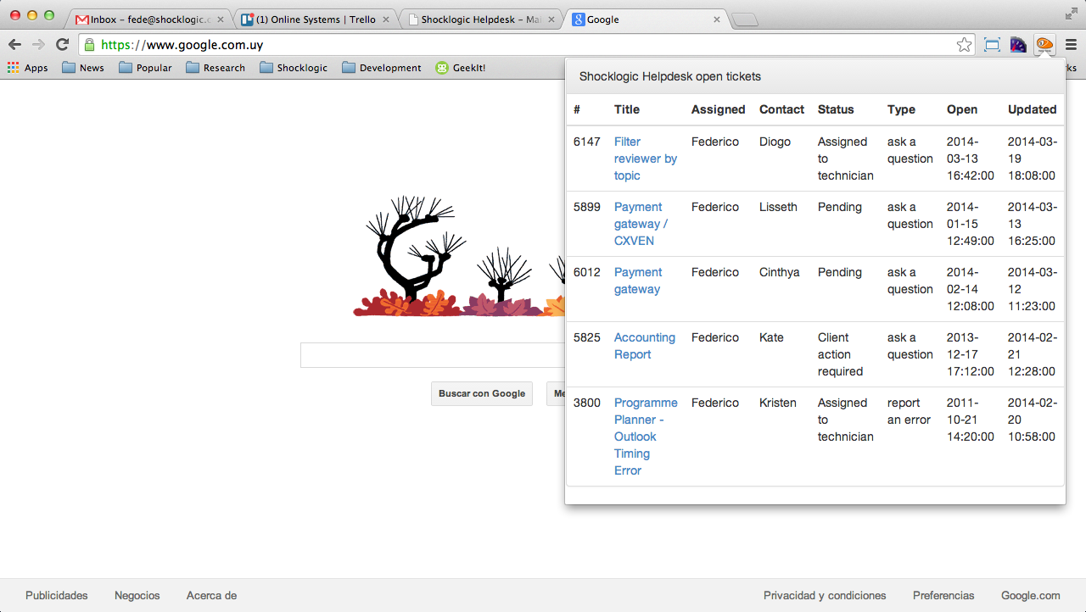

How to install?

- Go to https://helpdesk.shocklogic.com
- Login with your details
- Scroll down to the administration section of the menu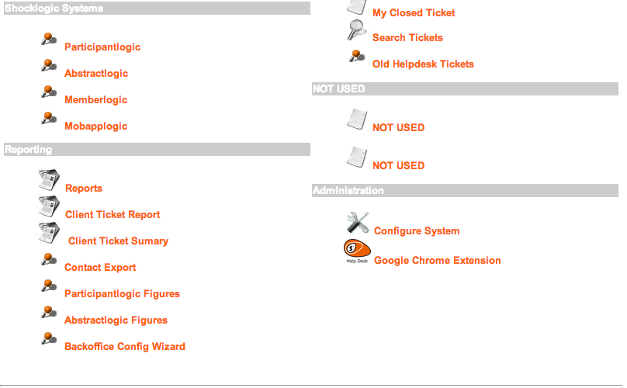
- Download the ShocklogicHDChromeExtension.zip to your computer
- Unzip the contents somewhere on your hard drive
- Open a new tab in Google Chrome and go to chrome://extensions
- Tick the box developer mode on the right hand side
- Click on “Load unpacked extension”
- Look for the folder where you unzipped the extension and click select
- You should see the extension on your extension list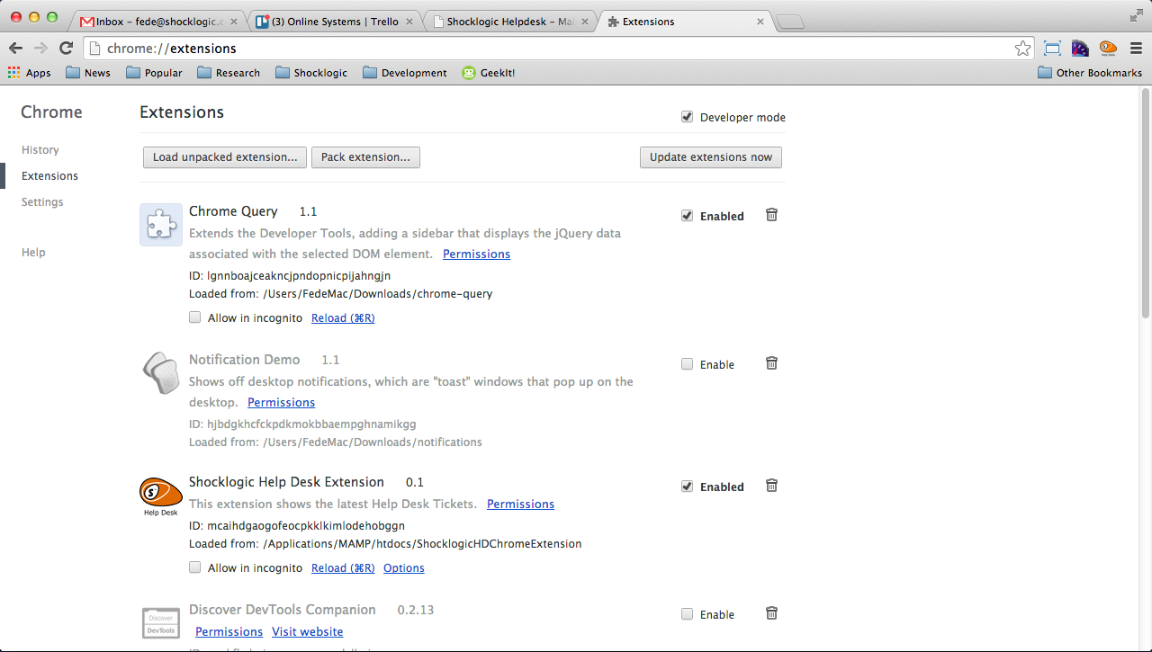
- Click on the options link in the extension
- This will open a new tab, in here you should enter your Help Desk login details.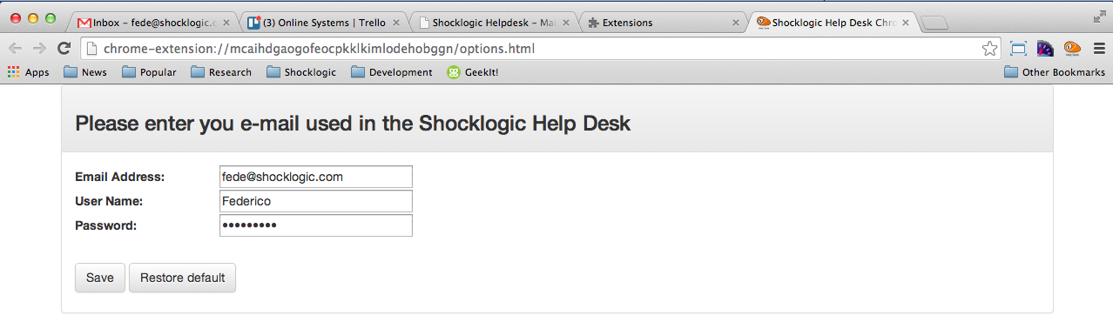
- Click Save.

Once you’ve done all this, you will be able to use the extension.

When looking at the tickets list in the extension, you can click on the title of a ticket and it will log you in directly in the Help Desk so you can update the ticket.

